Achieving meaningful transformation requires more than defining a strategy; it demands a disciplined framework that links strategic intent to measurable impact.

This Module introduces how to define Strategies, Perspectives, Objectives, and KPIs in PxM, cascade them across the organization, and align both demand and projects to strategic outcomes. It provides business leaders and PMO professionals with a structured approach to governing performance and ensuring enterprise-wide strategic alignment.
Pxm learning guide
Strategy Management Module

Contents
I. Strategy Management 2
1. Strategy Management Overview 2
2. How to Build Strategies in PxM 4
Setting Up Strategic Frameworks and Themes 4
Aligning Portfolios and Projects to Strategy 18
Measuring and Tracking Strategy Performance 19
Defining KPI Collection Process for Manual KPIs 19
Defining Power Automate Flows to Collect Automated KPIs 19
Defining KPI Measurement Approval and Publishing Process 19
Reference: Strategy Management Domain Model & Definitions 20
Domain Model Overview 20
Entities, Fields and Relationship Definitions 20

Strategy Management

Strategy Management Overview
Applies to: PxM SPM P1, PxM SPM P2, PxM Premium
Business Professional Focus: Ensuring all investments and initiatives align with strategy
In today’s data-driven business environment, organizations operate in an increasingly complex ecosystem of competing priorities, evolving markets, and accelerating digital transformation. Business leaders and consultants alike face the challenge of translating strategic intent into measurable action while maintaining agility and accountability.
Achieving this requires not only clear strategic direction but also transparent governance, data intelligence, and real-time insight into how every initiative contributes to enterprise value.
In practice, this means understanding where initiatives originate and how they connect back to strategy. Organizations pursue countless initiatives to deliver value, drive growth, and achieve transformation. These initiatives often originate from two primary sources:
- Strategy-driven initiatives – defined during the formulation of the organization’s strategy, when leadership identifies goals and objectives and builds a roadmap of initiatives to bring that strategy to life.
- Demand-driven initiatives – generated organically across departments and business functions during annual planning cycles, as teams propose new projects or investments to address emerging needs or opportunities.
In both cases, alignment with the overall strategy is critical. PxM’s Strategy Management module ensures that every initiative – whether born from top-down strategic planning or bottom-up functional demand – contributes meaningfully to organizational objectives.

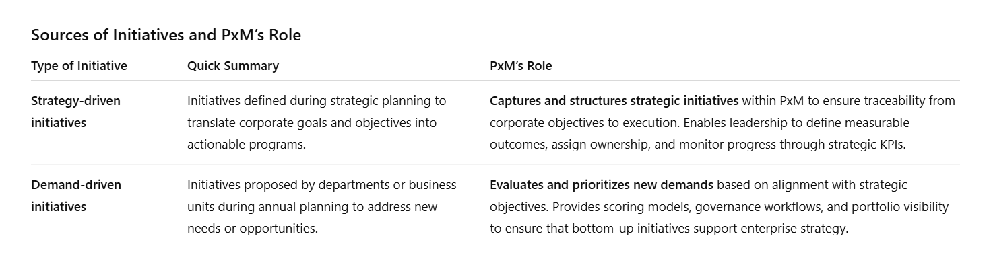

With a clear link between strategic intent and execution established, PxM operates as a role-based ecosystem. Multiple stakeholders – such as PMO Leaders, Portfolio and Project Managers, CFOs, CTOs, and Strategy and Performance Officers – each interact with the platform according to their specific goals and responsibilities. Through this collaborative environment, they make investment decisions that are transparent, data-driven, and aligned with business priorities.

What Strategy Management in PxM is: Balanced Scorecard framework for defining strategies, perspectives, objectives, and KPIs
PxM’s Strategy Management Module is built on a Balanced Scorecard framework that enables organizations to translate strategic vision into actionable, measurable objectives. It provides a structured approach for defining strategies, perspectives, objectives, and key performance indicators (KPIs) that connect every level of the enterprise – from corporate leadership to individual contributors – within one unified system.
The module supports managing strategic, corporate, departmental, and individual objectives. At the highest level, executives define the corporate strategy and long-term goals that guide the organization’s direction. PxM then allows these objectives to be cascaded to departments, programs, and even individual roles, ensuring that each team’s activities directly contribute to the achievement of enterprise goals.
By linking perspectives such as financial sustainability, business capability growth, customer experience improvement, innovation and competitive advantage, PxM provides a holistic view of how success is measured and sustained. Business users can:
- Define and structure objectives across different perspectives and hierarchy levels.
- Set measurable KPIs that reflect progress toward each objective.
- Cascade and align goals to maintain visibility and accountability across the organization.
- Monitor and update performance dynamically as strategies evolve.

Key benefits of Strategy Management and alignment in PxM
Through PxM, strategy management becomes a continuous governance process rather than a static annual exercise. The platform helps organizations:
- Connect strategy to execution, translating goals and objectives into actionable portfolios and projects.
- Evaluate new demand requests against strategic criteria, ensuring that only initiatives aligned with the company’s vision are approved.
- Maintain enterprise-wide alignment, where every investment, project, and resource allocation supports measurable strategic outcomes.
Ultimately, PxM enables organizations to manage the entire strategy value chain within a unified system – from strategic planning, through portfolio and project execution, to performance tracking and benefit realization. This integrated, role-aware environment ensures that every persona – whether defining long-term objectives, prioritizing investments, or assessing outcomes – has the visibility, tools, and insights needed to make data-driven decisions that align with enterprise priorities and deliver measurable business value.

How to Build Strategies in PxM

Setting Up Strategic Frameworks and Themes
PxM provides a structured environment for building strategies based on the Balanced Scorecard framework. This framework allows organizations to translate strategic vision into measurable objectives and KPIs, ensuring alignment from the corporate level down to departments and even individual contributors.

Defining the Strategic Foundation: Mission, Vision, and Time Horizon
Start by creating the foundation of your strategy: define your organization’s mission, vision, and strategic time horizon.
In PxM, these elements outline the purpose and scope of your strategy, defining what your organization wants to achieve and by when.

Tip: The time horizon typically spans three to five years, depending on the scale of transformation or growth your strategy targets.

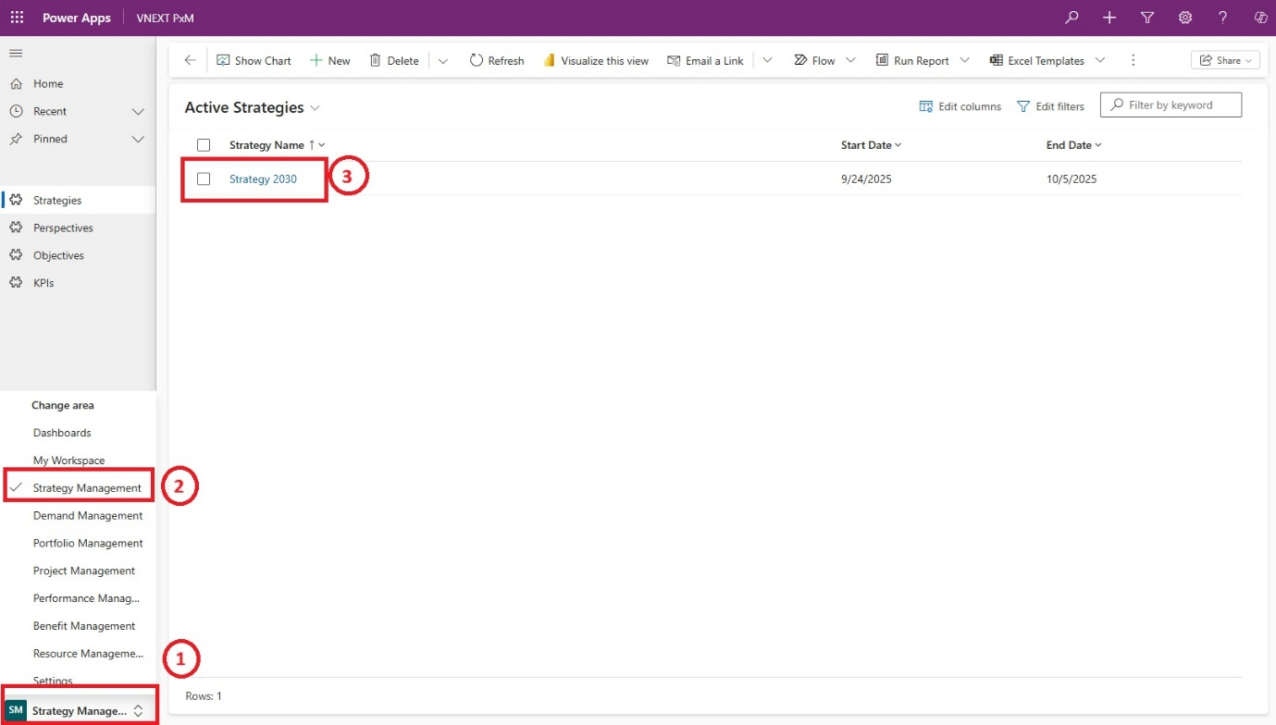
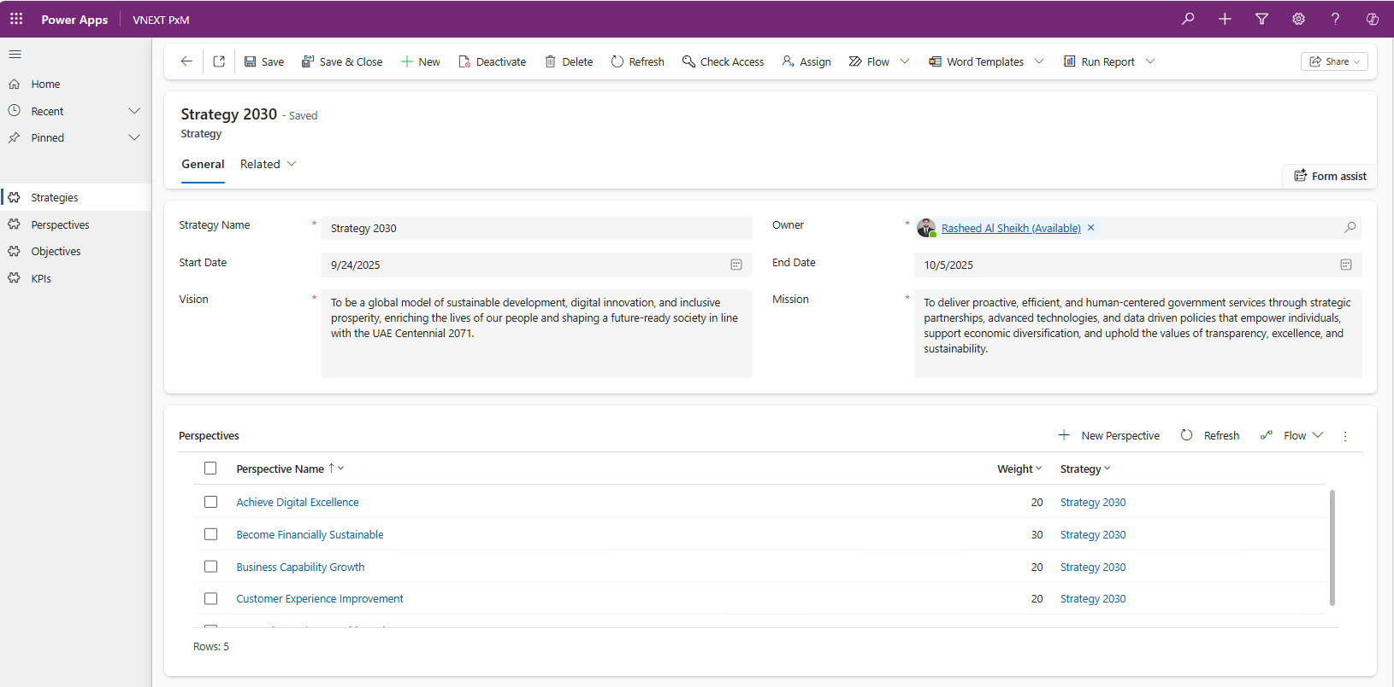

Defining the Strategic Perspectives
Next, structure your strategy through perspectives – the lenses through which your organization evaluates performance. PxM uses the Balanced Scorecard model by default but allows full customization to fit your organizational context.
Common perspectives include:
- Achieving Digital Excellence
- Ensuring Financial Sustainability
- Improving Customer Experience
- Growing Business Capabilities
- Driving Innovation

Note: PxM supports adding or adjusting perspectives to match your ambitions – some organizations might define up to seven or eight perspectives depending on their goals.

Each perspective can carry a weight, allowing you to define whether your strategy is perfectly balanced (e.g., 25–25–25–25) or intentionally unbalanced, prioritizing certain dimensions like financial performance or innovation.
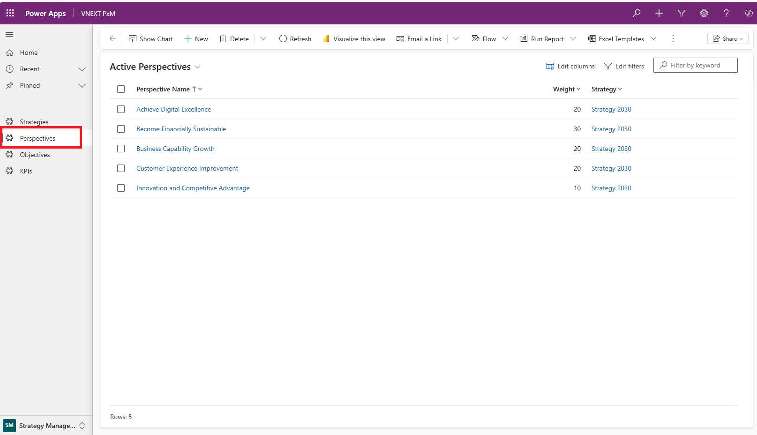
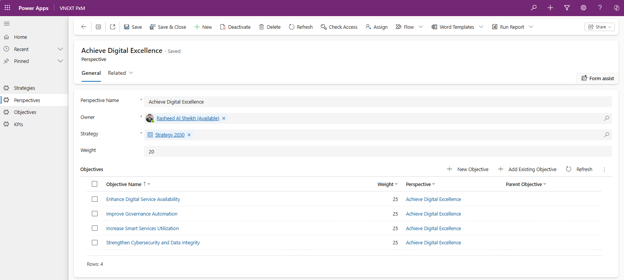

Defining SMARTER Strategic Objectives per perspective
Under each perspective, define specific objectives that capture measurable business outcomes. PxM allows objectives to be structured hierarchically – you can create parent and child objectives to reflect cascading accountability and dependencies.
Each objective can also be assigned a weight, indicating its relative importance within the strategy. Weighting enables organizations to emphasize certain objectives such as innovation or financial sustainability over others, depending on strategic priorities. These weights are later aggregated to calculate overall performance within each perspective.
Use the SMARTER principle when defining objectives:
- Specific – clearly defines what is to be achieved
- Measurable – includes quantifiable indicators
- Achievable – realistic within available resources and time
- Relevant – directly aligned with strategic priorities
- Time-bound – has a clear strategic horizon
- Evaluated – progress is regularly assessed and recalibrated
- Reviewed – outcomes are analyzed to refine future strategies


Example: Under the “Customer Experience Improvement” perspective, an objective could be “Improve customer satisfaction across channels.” This objective could carry a weight of 30%, reflecting its significance relative to other strategic objectives within the same perspective.
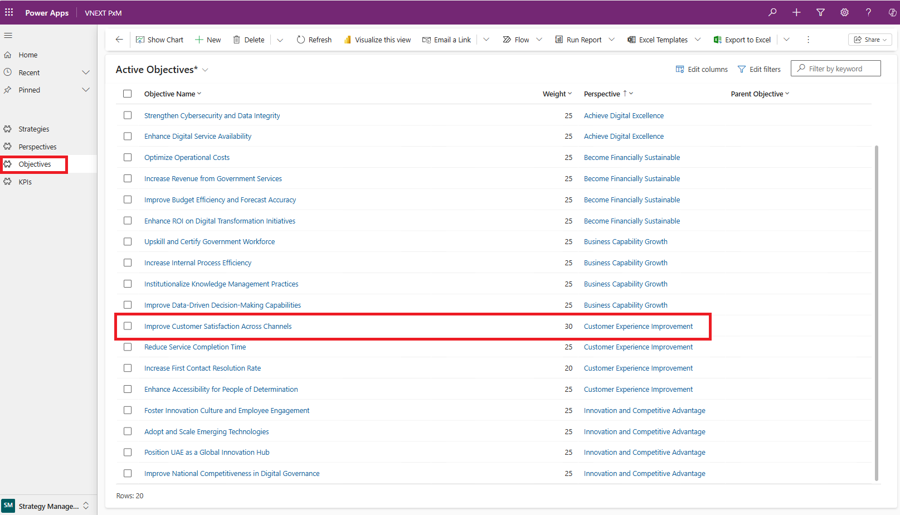
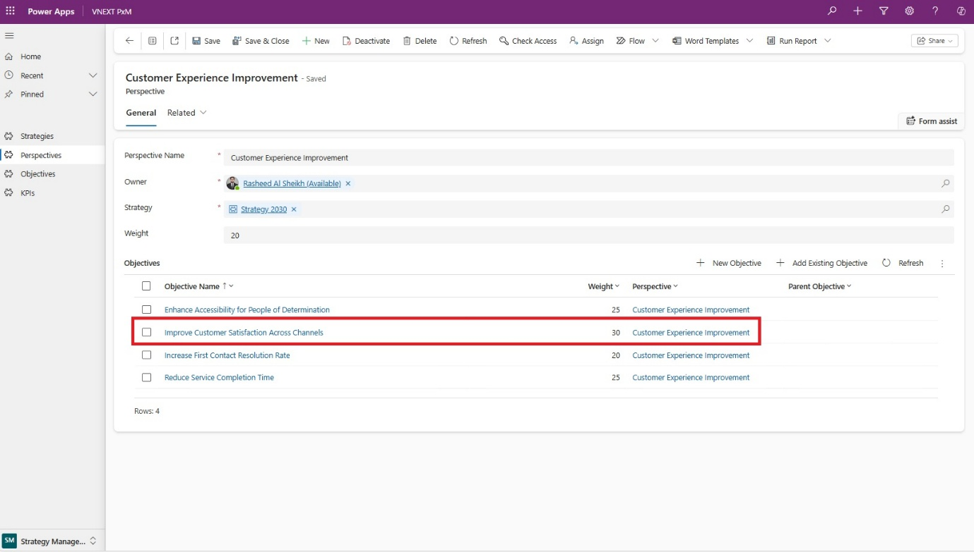
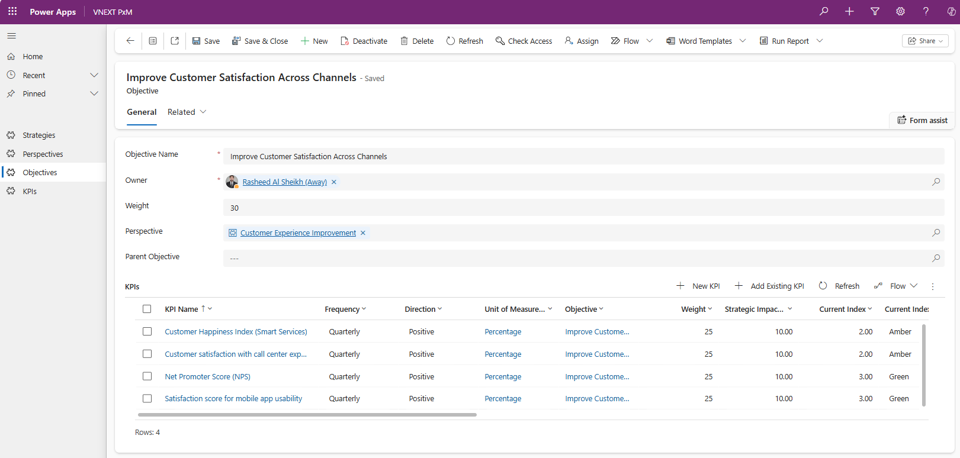

Defining KPIs to measure Strategic Objectives
Once strategic objectives are defined, the next step is to establish Key Performance Indicators (KPIs) that measure whether those objectives are being achieved. KPIs translate strategy into measurable outcomes, providing the quantitative evidence needed to assess progress toward organizational goals.
To ensure consistent tracking and evaluation, each KPI should be defined with a clear formula, performance thresholds, and a measurement cadence – all of which will be elaborated on in the below listed steps. Within PxM, KPIs are further enhanced by assigning owners, setting time horizons, and applying weighting factors – ensuring accountability, prioritization, and accurate performance aggregation across the enterprise. PxM provides a structured, data-rich environment for creating, tracking, and analyzing KPIs with full transparency.
Before diving into the detailed setup process, it’s important to note that PxM also enables cascading KPIs across organizational units. This ensures that enterprise-level objectives are systematically translated into departmental and team-level performance measures. Through this cascading capability, PxM aligns individual contributions with corporate strategy, allowing every unit to understand its impact on broader strategic outcomes.
Now that we’ve covered the purpose and structure of KPIs, let’s explore the key steps involved in defining and operationalizing them within PxM. To reinforce these concepts, the example below demonstrates how a unified strategy cascades through each Perspective, Objective, and KPI to create a coherent Balanced Scorecard.
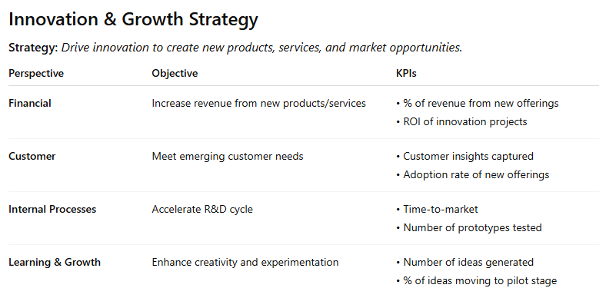

Step 1 – Identifying the right KPIs for each objective
Begin by selecting KPIs that directly measure whether each objective is being achieved. KPIs should be outcome-oriented, not merely activity-based.
For every objective, define indicators that reflect success in measurable terms – for example, under “Improve Customer Satisfaction Across Channels”, we have defined the following KPIs:
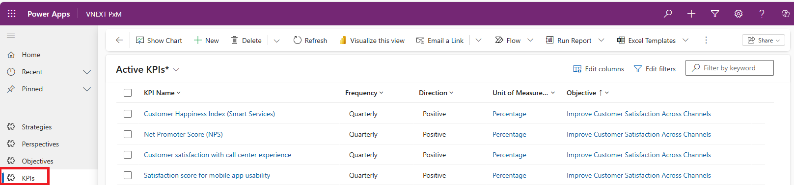

Step 2 – Setting baselines, targets, and timeframes
For every KPI, define where performance stands today (baseline), the target to be achieved, and the timeframe for achieving it. These parameters help quantify the expected improvement and ensure that progress can be tracked objectively over time.
Let's go back to the “Customer Happiness Index (Smart Services)” KPI which we have defined under “Improve Customer Satisfaction Across Channels” objective. This KPI will help us measure how satisfied customers are with the organization’s digital and automated service touchpoints.
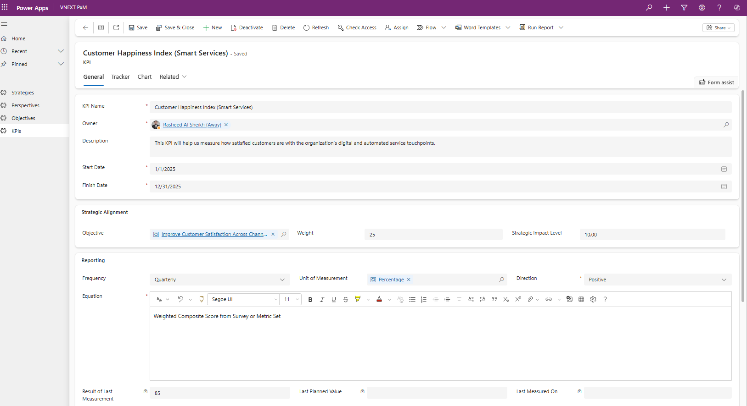
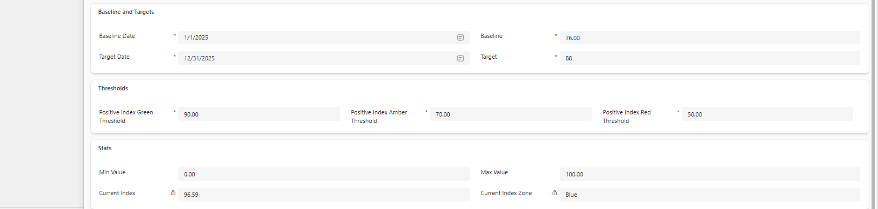
The baseline represents the current state of customer sentiment, while the target defines the desired improvement over the defined strategic horizon.
To bridge this gap between planning and performance, PxM enables business professionals to visualize the journey through progress charts and trackers, providing a clear line of sight between the KPI, its contributing initiatives, and the strategic objective it supports.
Tip: Always ensure that KPI targets align with both the overall strategy timeline and the measurement cadence (e.g., monthly or quarterly reviews) to maintain consistent performance evaluation across all perspectives.

Step 3 – Defining KPI properties and metadata
In PxM, each KPI is treated as a detailed performance entity enriched with metadata to support governance, traceability, and analytics.
The table below outlines the key properties to define when setting up KPIs in PxM.
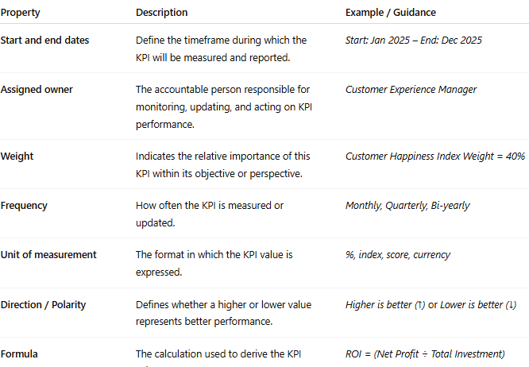

Tip: Standardizing KPI metadata ensures clarity, consistency, and comparability across all strategic perspectives. PxM automatically leverages this information for performance roll-up and dashboard reporting.

Step 4 – Configuring thresholds and strategic impact
To bring KPIs to life, define thresholds that classify performance zones:
- Green (Target achieved) – performance meets or exceeds expectations
- Amber (Caution) – performance near target; attention required
- Red (Critical) – performance below target; corrective action needed
Each KPI can also carry a strategic impact score, showing how strongly it influences higher-level objectives or perspectives. PxM uses these weights and impact factors to calculate overall performance roll-ups within dashboards.
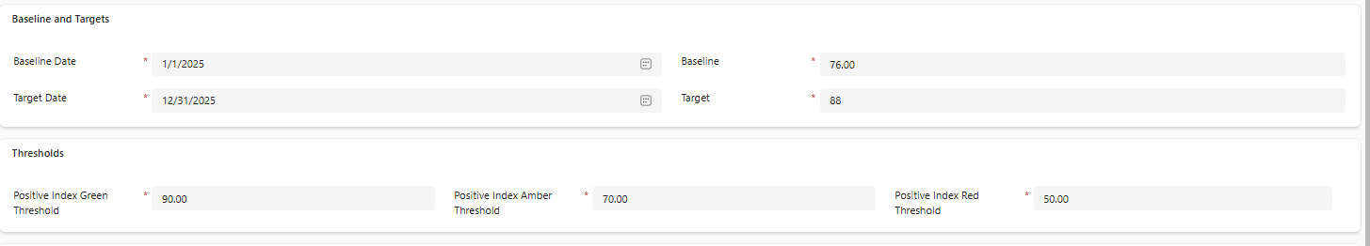

Step 5 – Tracking and trending KPI results
Once KPIs are defined and operationalized, PxM provides multiple approaches to track, update, and visualize their performance – ensuring that progress toward strategic objectives is continuously monitored.
Manual Tracking:
In PxM, KPI tracking can be performed manually by the designated KPI owners or performance officers.
This approach is particularly useful when:
- KPIs rely on qualitative or judgment-based assessments (e.g., stakeholder satisfaction, leadership maturity, innovation readiness).
- Data sources are non-automated, or when KPIs are in the early stages of definition and lack structured data feeds.
- Business users need flexibility to enter and validate performance results directly within the PxM interface.
Manual tracking enables transparency and accountability – KPI owners can log current values, update baselines, and adjust targets as required. Each entry is timestamped and stored for auditability, allowing PxM to trend historical data and visualize performance over time.

Automated Tracking:
For organizations operating with mature data systems, PxM also supports automated KPI tracking through integrations and data connectors. This enables PxM to automatically pull performance data from operational or analytical systems such as:
- Microsoft Planner, Azure DevOps, or Jira (for schedule and delivery-based KPIs)
- ERP and Financial Systems (for cost, revenue, or budget utilization metrics)
- HR or Resource Management tools (for capacity, utilization, and skill KPIs)
- BI Platforms and Data Warehouses (for aggregated performance indicators)
Automation ensures that KPI data remains current, accurate, and consistent, minimizing manual entry effort while strengthening governance. PxM continuously aggregates data from connected systems, calculates weighted performance scores, and updates dashboards in real time.

Trending and Performance Visualization:
Whether tracked manually or automatically, PxM provides robust visualization tools to help stakeholders interpret performance data effectively through “Tracker” and “Chart” features. These visual insights help Strategy Managers and Executives identify trends, diagnose performance issues, and link results directly to the initiatives and portfolios that drive them.

Note: Many organizations begin with manual KPI tracking during early strategy cycles to refine definitions and data quality, then progressively automate once stable data pipelines and governance models are in place. PxM supports both modes seamlessly – enabling organizations to mature their performance management capabilities at their own pace.

Step 6 – Reviewing and Recalibrating KPIs
As business conditions evolve, revisit your KPIs to ensure they remain relevant. PxM facilitates ongoing evaluation and recalibration, allowing you to:
- Adjust weights or targets based on strategic priorities
- Modify formulas or measurement frequencies
- Retire or replace KPIs that no longer serve the intended objective
This ensures that strategy measurement remains a living process, aligned with real-world performance and organizational focus.

Cascading KPIs to Organizational Units
Strategic performance is only as effective as its execution across the organization. PxM ensures that enterprise strategies are not confined to executive dashboards but are cascaded through every level of the organization – from corporate objectives down to departmental KPIs.
Ensuring Organizational Strategic Alignment
PxM helps enforce Organizational Strategic Alignment by capturing and maintaining digital records of the organization’s complete strategy map. This map visualizes how high-level strategic objectives flow downward into measurable KPIs, programs, and projects – ensuring that every activity within the enterprise directly contributes to the achievement of organizational goals.
Through its Strategy Management framework, PxM allows organizations to:
- Digitally record strategic objectives, perspectives, and KPIs.
- Map these objectives and measures against the organizational hierarchy, from the enterprise level to business units, departments, and even individual teams.
- Link initiatives, portfolios, and benefits to the strategic outcomes they are designed to deliver.
This creates a traceable line of sight – where leadership can clearly understand how every initiative impacts strategy, and departments can see how their work supports the broader mission.
Example: A corporate objective like “Enhance Customer Experience” may cascade into departmental KPIs such as “Reduce Service Resolution Time” (Operations) or “Increase Digital Channel Satisfaction” (IT/Customer Support).

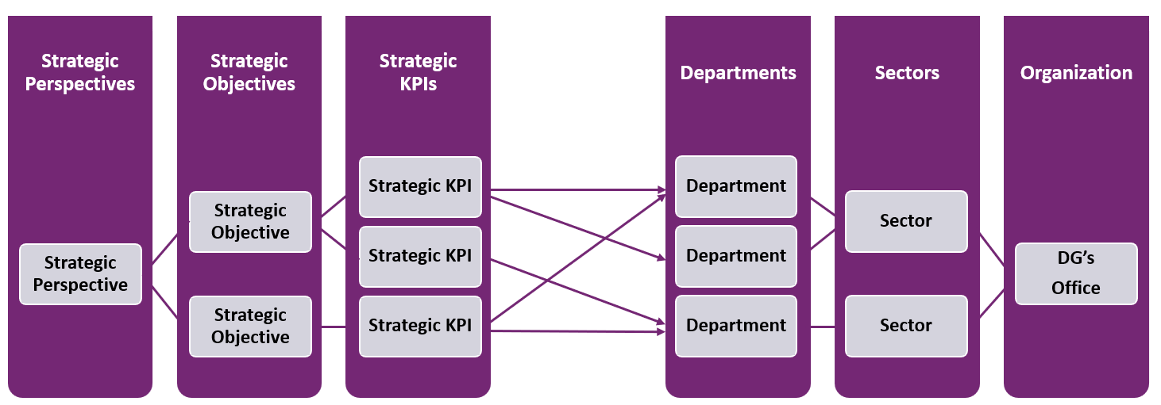

Mapping Strategic Objectives and KPIs Across the Organization
In PxM, cascading strategy is achieved by mapping objectives and KPIs to the organizational structure. Each department’s objectives are directly linked to the higher-level goals they contribute to. This ensures that demand is evaluated not in isolation, but within the context of the department’s strategic role and contribution to enterprise outcomes.
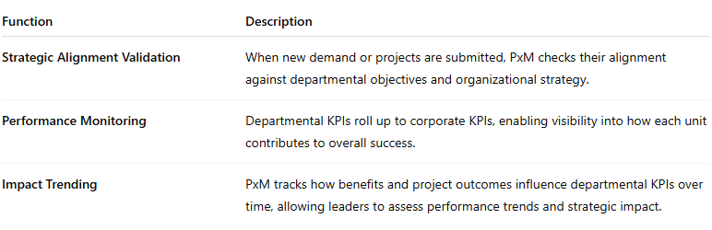

From Demand to Performance: An Integrated Performance Management Framework
The cascading model in PxM creates an integrated performance management framework that connects strategy, execution, and performance:
- Strategic Planning: Enterprise objectives and KPIs are defined.
- Cascading Alignment: These KPIs are assigned to departments, creating accountability and localized ownership.
- Demand Evaluation: When new demand arises, PxM evaluates its strategic fit against departmental objectives and drivers.
- Execution and Monitoring: Approved demands become projects whose outcomes are tracked for their impact on KPI improvement.
- Performance Review: Results are aggregated and trended upward to inform enterprise-level decision-making.

Note: In effect, PxM transforms strategy into an operational fabric – ensuring every demand, project, and benefit contributes measurably to organizational success.

Example: Defining “Operational Excellence” linked to Cost Reduction and Productivity Objectives and KPIs
To illustrate how PxM translates strategic intent into measurable performance, let’s take the Operational Excellence perspective as a practical example.
Step 1 – Defining the Strategic Objective
Operational Excellence represents the organization’s commitment to improving efficiency, optimizing resources, and enhancing quality across operations. In PxM, this objective would typically be defined under the Internal Process or Operational Efficiency perspective.

Example: Achieve Operational Excellence by enhancing process efficiency and reducing operational costs across all business functions.

Step 2 – Linking to Cost Reduction and Productivity KPIs
Under the Operational Excellence objective, PxM enables the creation of Key Performance Indicators (KPIs) that quantify progress. Examples:

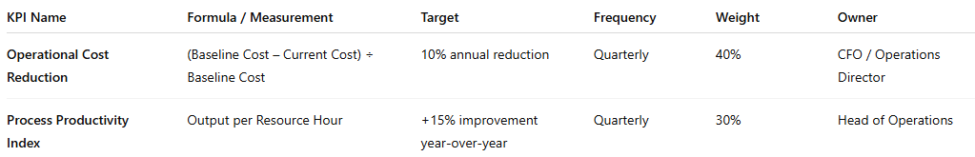

Tip: PxM allows each KPI to include formulas, baselines, targets, and frequency definitions. Weighting factors ensure that financial and operational KPIs contribute proportionally to the overall objective score.

Step 3 – Mapping Across Organizational Units
In PxM, the Operational Excellence objective and its KPIs are cascaded across relevant departments, ensuring alignment and accountability:
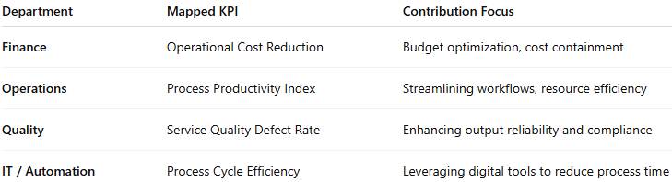

This cascading ensures that every department contributes measurable value to the enterprise’s operational performance targets.

Step 4 – Monitoring and Trending
PxM continuously tracks KPI performance using dashboards, scorecards, and trend charts.
- Variance-to-target indicators highlight underperformance early.
- Drill-down views enable investigation by department or project.
- Real-time integration with ERP or analytics systems ensures accuracy and timeliness.

Outcome
Through PxM, Operational Excellence evolves from a high-level objective into a disciplined, data-driven performance framework. Each KPI becomes a quantifiable indicator of progress, every department is accountable for measurable outcomes, and leadership gains a comprehensive, analytics-driven view of how operational efficiency translates into financial returns and strategic impact.

See Also: Strategy Management Overview

See Also: Strategy Performance Dashboards

Aligning Portfolios and Projects to Strategy

Mapping Demand to Strategic Objectives by Linking Demand Benefits to Strategic KPIs Contribution

During the portfolio analysis phase, demands are assessed and prioritized based on weighted business drivers and their alignment with key strategic objectives. Once a demand is approved, it transitions into an executable project – preserving all its strategic context. PxM ensures that the benefits defined during the demand phase are automatically inherited by the resulting project, appearing under Project Strategic Benefits. This continuity guarantees full traceability between strategy formulation, investment decisions, and execution performance.
For detailed guidance on how new demand transitions into approved projects through portfolio analysis, refer to Portfolio Analysis section.

Mapping Demand to Strategic Objectives and KPI Contribution
To operationalize alignment, PxM enables users to map demand items and their benefits directly to strategic objectives and KPIs.
This mapping establishes a clear line of sight between why an initiative exists and how it contributes to the measurable outcomes defined in the strategy.
For example:
- A demand aimed at “Enhancing Customer Digital Experience” may be linked to the strategic objective “Improve Customer Satisfaction Across Channels”, and its benefits mapped to KPIs such as Customer Happiness Index and Service Response Time.
- Similarly, an initiative under “Operational Excellence” might contribute to KPIs like Cost Reduction and Process Productivity.
As projects progress, PxM continuously monitors benefit realization and trends their performance against these strategic KPIs. This allows leadership to identify which investments are generating the intended impact and which require corrective action.
Tip: This integrated mapping of demand, benefits, and KPIs allows PxM to quantify the strategic value of every project – turning qualitative ambition into measurable business outcomes.

See also: Portfolio Analysis
See also: Strategy Performance Dashboards
See also: Measuring and Tracking Strategy Performance
See also: Measuring and Tracking Project Benefits

Aligning Independent Projects to Strategy via Strategic Benefits and KPI Mapping

See also: Use Strategy Performance Dashboards to Track Coverage and Contribution
See also: Portfolio Analysis
See also: Strategy Performance Dashboards
See also: Measuring and Tracking Strategy Performance
See also: Measuring and Tracking Project Benefits

Measuring and Tracking Strategy Performance

Defining KPI Collection Process for Manual KPIs

Defining Power Automate Flows to Collect Automated KPIs

Defining KPI Measurement Approval and Publishing Process

See Also: Strategy Performance Dashboards

Reference: Strategy Management Domain Model & Definitions

Domain Model Overview

Entities, Fields and Relationship Definitions

